**PREMIER UNIVERSITY CHITTAGONG**

|  |
| --- |
| *Department of Computer Science & Engineering* |



***Laboratory Report***

***Course Title:*** Software Engineering and

Information System Design Laboratory

***Course Code:*** CSE-306

***Submitted For:***

Mr. Dhrubajyoti Das

Lecturer

Department of CSE

Premier University Chittagong.

***Submitted By:***

|  |  |  |  |  |  |
| --- | --- | --- | --- | --- | --- |
| Name | ID | Department | Batch | Semester | Section |
| Munem Sahriar | 1703310201525 | CSE | 33th | 5th | C5C |
| Istiyak Mahmud | 1703310201529 | CSE | 33th | 5th | C5C |
| Hemel Borhan | 1703310201532 | CSE | 33th | 5th | C5C |

***Date of Submission:*** 17-10-2020

**Introduction:**

In today’s everyday life, we come across many emergency situations such as accidents which cause bleeding and blood loss. Such issues create an immediate, critical need for blood supply of specific blood type as per the requirements of one in need. In addition to emergency requirements, advances in medicine have increased the need for blood in many on-going treatments and elective surgeries. This Project is to create an e-Information about the donor and finder that are related to donating blood. Though this project any person who is interested in donating blood can register himself. In the same way, if any blood finder who needs blood can send request for blood. Also a blood finder can find blood according to his needs/demand. Moreover a user can find blood bank location easily by using this software. A user can donate money for blood donation free campaign. Admin is the main authority who can do addition, deletion and modification if required.

**Objective:**

The main objective of this project is to develop a systemic blood donation and receiving Platform and Management System.

**Literature Review:**

The main purpose of our project to make a Blood Donation Application that is user friendly and has the intelligence to find the best matches of blood donors by analyzing the nearby donor’s profile. We believe that our Blood Donation Application will bring the donors and receives so close that blood donation will no longer be a matter of risk and worries. At the beginning of the project we have researched on some secondary resources based on this. From these sources, we have been able to know the existing functions and determined our work outline.

T.Hilda Jenipha and R.Backiyalakshmi [1], made a cloud based blood donation app and we get to know about this from their paper “Android Blood Donor Life Saving Application in Cloud Computing”. Where the contact details will appear in alphabetical order on the screen. In case of urgent blood requirement, one can quickly check for contacts matching a particular or related blood group and reach out to them via Phone Call/SMS through the Blood donor App. Their Blood Donor App provides list of donors in your city/area. According to them, Cloud- based services can prove important in emergency blood delivery since they can enable central and immediate access to donors' data and location from anywhere. Since almost everyone carries a mobile phone with them, it ensures instant location tracking. The location-based app, operational on android platform, will help users easily find donors of matching blood groups in their location and can be accessed via their mobile numbers.

From Shek and Shilpa [2] – the authors of “Android Blood Donor Life Saving Application in Cloud Computing” we can understand, the importance of having blood donation app. According to them, despite numerous significant achievements, the discipline of Supply Chain Management (SCM) is still incapable of satisfactorily addressing many practical, real-world challenges. The user’s location will be detected using GPS. If there is need of blood, the donor with the required blood group is identified and notified of the requirement. The project includes algorithm which detects accurate location of the donors, identifies the donors who are available nearby to the location of requester and notifies them. If the identified donors are not available or not willing to donate blood at present then the scope of detection is increased. This is done by increasing the scope of search. Notifying the donor about the need of the blood is the most important task of the system.

Snigdha, Pratiksha, Siddhi, Pranita and Varsha [3] thinks the problem is not insufficient number of donors, but finding a willing donor at the right time. They want to build a network of people who can help each other during an emergency. Their application timely updates the information regarding the donors where the administrator accesses the whole information about blood bank management system. Donor will be prompted to enter an individual's details, like name, phone number, and blood group. In the urgent time of a blood requirement, someone can quickly check for blood banks or hospitals matching a particular or related blood group and reach out to them through the App. Blood bank App provides list of blood banks in an area. They feel that, a large number of blood donors are attracted using an Android application. Since almost everyone carries a mobile phone with them, it ensures instant location tracking and communication. Only a registered person, with willingness to donate blood, will be able to access the service. In this application they are using the GPS technology that was been to trace the way to the blood bank. The user will get the route to reach the desired location and he won't have to ask manually, therefore time can be saved.

Again, from the source[4] a paper called” Blood donation system for online users”, we have known that most of people desire to know about online blood donation to the patients at once. Patients want to get blood to live at emergency time. At present people are needed to know how to contact blood donors online. This system provides how to get blood at their serious time. Matcher system is implemented with Decision Tree and Decision Table by rules. This matcher applies the rules based on Blood Donation in Blood Bank in Myanmar. Information about donors and patients has been reserved in the system so that it is ready to donate blood instantly.

**Features:**

**Features for user:**

* Registration and Login as a Donor.
* Blood Request Send.
* Searching and Finding Blood.
* Send Email by smtp phpmailer.
* Blood bank Location map and details.
* Donate Money with Card.
* Important Blogs about Blood Donation

**Features for Admin:**

* Login as a Admin/Volunteer
* Delete donor information.
* Managing Donor for blood request.

**Methodology:**

**Process Model:**

In this Software development Project, we designed, Implemented and tested incrementally until the project submission date. We do both development and maintenance. we broken down the system development into many mini development and highest priority requirement tackled first. Then marge the partial systems successively to produce the final total system. As we described, we followed the incremental model to develop this software.

**Use Case Diagram:**

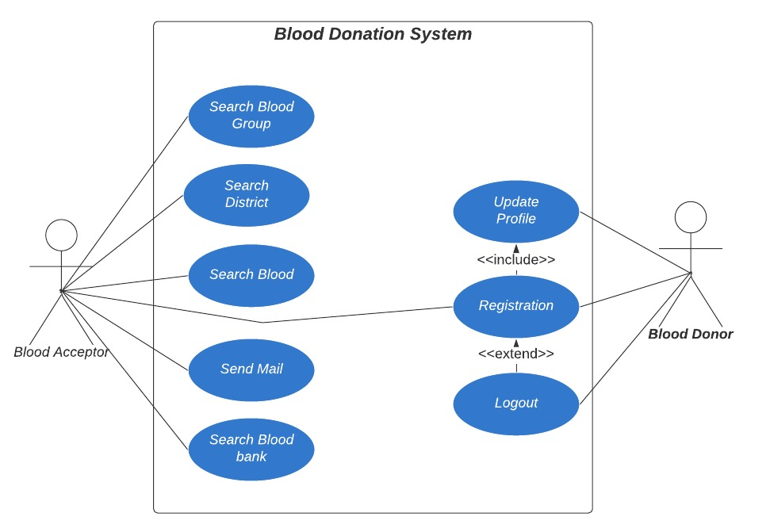

Fig: Use case Diagram

**ER Diagram:**

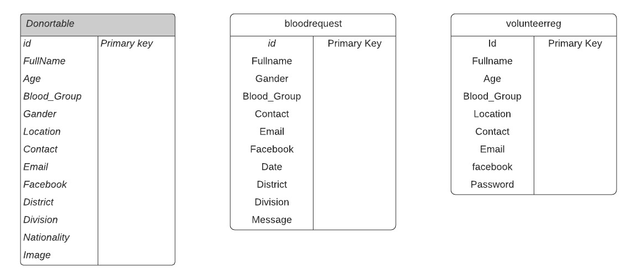

Fig: ER Diagram

**Activity Diagram:**

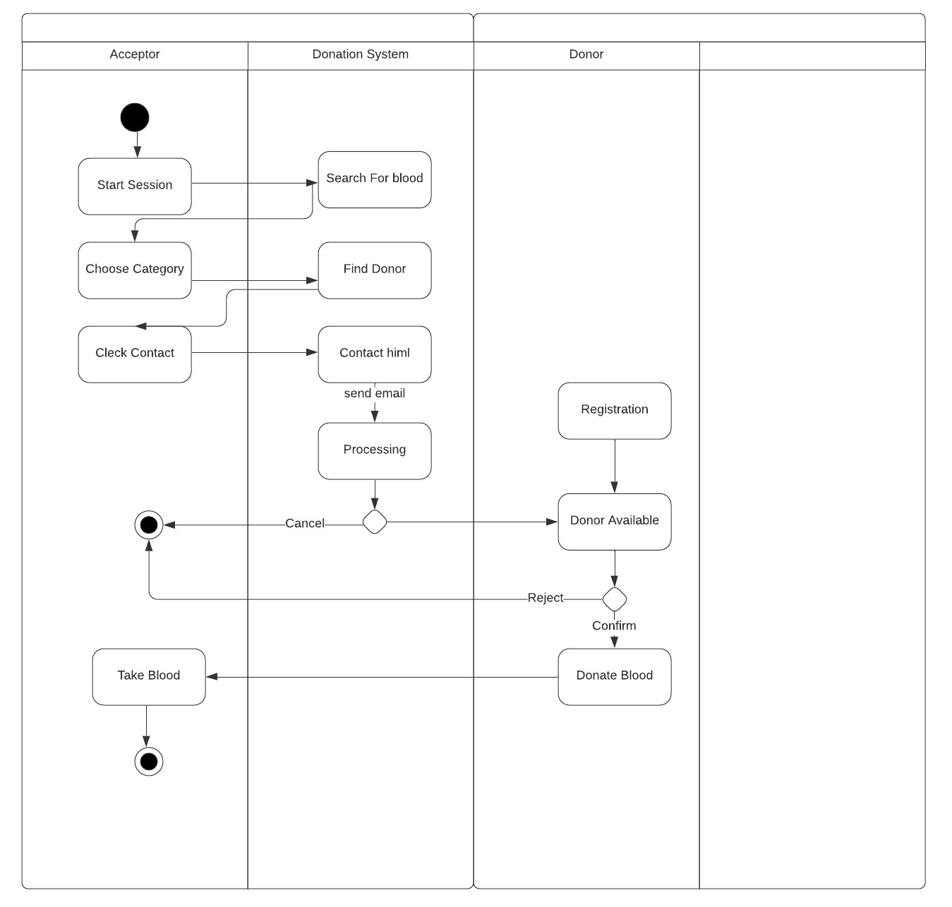

Fig: Activity Diagram

**Logical DFD:**

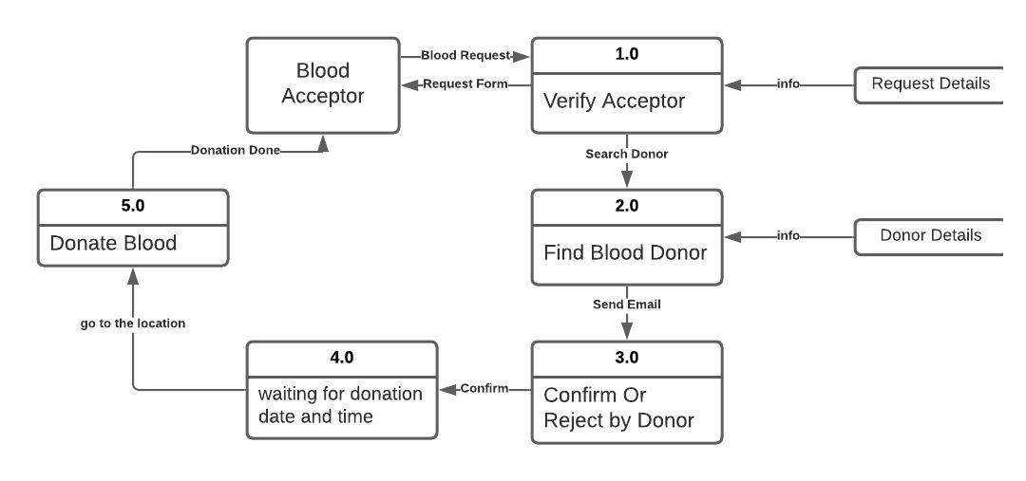

Fig: Logical DFD

**Limitations and Future Work:**

**Limitations:**

* Mailing system is not connected with Contact(Find Donor)

**Future Work:**

The Blood Donor App puts the power to save lives in the palm of your hand. Donating blood and platelets is easier than ever. Find nearby Red Cross blood drives, schedule appointments, earn rewards from premier retailers, and follow your blood’s journey from donation through delivery (when possible), and create or join a lifesaving team and track its impact on a national leader board. The future plan is this:

1. Send Push Notification to the persons Contact Number who are selected and connection will be established.
2. There will be a request and accept button for sending and receiving push notification.
3. “Near by” Option. Blood Finder may find a donor in around 1 kilometers area.
4. The Complete Software will be developing for whole human Health issues. Blood Donation wills just a part of this.

**Consolation**:

The aim of this Blood Donation Software is to improve the communication with the people who are in need of blood and the persons who are willing to donate blood in few touches of Software. This Location based Blood Donation Software will reduce the barrier between blood donors and the people in sever need of blood. The donors’ location can be detected by the app and the best matched donor will be contacted in no time.

The blood donation Software we are making puts the power to save lives in the palm of your hand. Donating blood and blood components are easier than ever. A person just needs to have an account in our Blood Donation Application, then he can both donate and request for blood anytime. “BlueBlood” is a free blood Donation Software available. Blood Donor searches, notifies and connect thousands of blood donors in some simple steps. Blood Donor donation app ensures hassle free blood donation and privacy of a blood donor. Connecting blood donors and needy reduces time which increases the possibility of saving lives and also eliminates the shortage of blood.

**References**:

* [www.google.com](http://www.google.com)
* <https://getbootstrap.com>
* <https://w3schools.com>
* [www.youtube.com](http://www.youtube.com)
* [www.GitHub.com](http://www.GitHub.com)
* <https://lucid.app>